The Biotech Capital Group
NanoViricides, Inc.

Equity Research Report

Table of Contents
Disclosures………………….. 2
Corporate Background………. 3
Financial Models……………. .8
Technical Analysis………….. 22
Recommendation and
Price Target…………………..28

EQUITY RESEARCH REPORT DISCLOSURES
Our mission in Equity Research is to provide our clients with strong leadership and guidance in the investment process. Therefore, it is vital that our clients and investors have confidence and trust in the research The Biotech Capital Group provides. To achieve this, we instill and support a philosophy of independence, objectivity and credibility. The reputation of our business depends on it.
High analyst standards together with appropriate compliance policies, disclosure and transparency are crucial to the integrity of our business practices. We have implemented responsible policies and procedures to address potential conflicts of interest and ensure responsible research.
The Biotech Capital Group’s core value is “Integrity: We act with integrity and professionalism in everything we do.” We strive to live up to this core value.
Our Analysts must adhere to strict and comprehensive standards and disclosure policy. The following are the key aspects of our policy:
- Analysts are prohibited from acting as directors or officers of companies
- Analysts are prohibited from trading contrary to their recommendations
- On every research report, The Biotech Capital Group discloses whether an Analyst or Associate or one of his/her related accounts has a financial interest in the securities they cover
- All research reports and recommendation changes are approved by the head of Equity Research or the Supervisory Analyst prior to publication
- Analyst’s draft reports are closely supervised. Draft reports may be reviewed for factual accuracy. Draft reports may be sent to the Corporate Issuer for review of accuracy of factual information only. Any subsequent recommendation or target price changes are reviewed by the Supervisory Analyst
- All of our research is made available to our clients entitled to receive it
- We disclose when The Biotech Capital Group expects to receive or intends to seek compensation for services rendered to the issuer covered in the research report within the next three months
- All disclosures are prominently disclosed in every research report
- The Biotech Capital Group does NOT receive compensation EXPLICITLY for research reports and NanoViricides, Inc. DID NOT compensate The Biotech Capital Group for this research report. However, The Biotech Capital Group is in contract with NanoViricides, Inc. to assist in the raising of capital for the continuation of Nanoviricide's research. Furthermore, BCG does NOT receive monthly or yearly retainer fees as a result of this agreement.

CORPORATE BACKGROUND OF NANOVIRICIDES, INC

SUMMARY
NanoViricides, Inc. (herein referred to as “Company”, OTCBB:NNVC) is a biopharmaceutical company developing nano-technology-based anti-viral medicines. Their drugs employ a systems-biology-based mechanism of action; called “nanoviricides (™)” (nanotechnology-enabled, targeted viricides, i.e., virus-killing agent). A nanoviricide targets, engages, encapsulates and destroys the target virus. What is a nanoviricide? A NanoViricide is a bio-mimetic. In other words, the virus thinks the Nanoviricide is a cell and treats it as such. Using a bio-mimetic enables the nanoviricide to maintain its effectiveness even if and when the virus mutates.
NNVC currently has drug candidates against: (1) Influenza, (2) HIV, (3) EKC—an aggressive form of “pink eye”, (4) Bird Flu (H5N1) and other Highly Pathogenic Avian Influenzas, and (5) Rabies. Additional projects underway include Herpes Simplex viruses, Hepatitis C, Dengue virus and Ebola/Marburg virus. Exploratory projects include Multiple Sclerosis and common colds.

Corporate History of Nanoviricides, Inc.
Nanoviricides, Inc. is a developmental stage biotechnology company. NNVC was incorporated in Nevada on April 1, 2005. The Company is publicly traded on the OTCBB under the symbol NNVC. Nanoviricide was formed in May 2005 with exclusive, perpetual licenses to anti-viral drug development technologies and intellectual property from TheraCour Pharma, Inc. It was taken public via reverse merger with a public shell company in June 2005. This public shell was Edot-com.com, a public shell incorporated in Nevada on April 1, 2005, for the purpose of conducting internet transactions. NNVC acquired Edot-com.com through a Plan of Share Exchange. Nanoviricides became fully reporting in November 2006.
Viral Targets of NanoViricides, Inc.
NanoViricides is currently working on drug candidates for several highly infectious diseases. In order to truly appreciate the Company’s technology, one must become familiar with the viruses they seek to treat. NNVC currently is engaging in pre-clinical development to further develop lead drug candidates that utilize their technology against two well known viruses; HIV and H5N1 (among others). A closer examination of each of these is required to gain a full understanding of what NNVC is attempting to accomplish.
HIV
Human Immunodeficiency Virus is a retrovirus that can lead to acquired immunodeficiency syndrome (AIDS), a condition in humans in which the immune system begins to fail, leading to life-threatening opportunistic infections.
HIV primarily infects vital cells in the human immune system such as helper T cells (specifically CD4⁺ T cells), macrophages and dendritic cells. HIV infection leads to low levels of CD4⁺ T cells through three main mechanisms: primarily, direct viral killing of infected cells; secondly, increased rates of apoptosis in infected cells; and thirdly, killing of infected CD4⁺ T cells by CD8+ cytotoxic lymphocytes that recognize infected cells. When CD4⁺ T cell numbers decline below a critical level, cell-mediated immunity is lost, and the body becomes progressively more susceptible to opportunistic infections.
HIV enters macrophages and CD4⁺ T cells by the adsorption of glycoproteins on its surface to receptors on the target cell followed by fusion of the viral envelope with the cell membrane and the release of the HIV capsid into the cell. Once the viral capsid enters the cell, an enzyme called reverse transcriptase liberates the single-stranded (+)RNA from the attached viral proteins and copies it into a complementary DNA. This process of reverse transcription is extremely error-prone and it is during this step that mutations may occur. Such mutations may cause drug resistance.
H5N1 (Bird Flu)
HPAI A(H5N1) is an avian disease. There is some evidence of limited human-to-human transmission of the virus. A risk factor for contracting the virus is handling of infected poultry, but transmission of the virus from infected birds to humans is inefficient. Still, around 60% of humans known to have been infected with the current Asian strain of HPAI A (H5N1) have died from it, and H5N1 may mutate or reassort into a strain capable of efficient human-to-human transmission.
Due to the high lethality and virulence of HPAI A(H5N1), its endemic presence, its increasingly large host reservoir, and its significant ongoing mutations, the H5N1 virus is the world's largest current pandemic threat, and billions of dollars are being spent researching H5N1 and preparing for a potential influenza pandemic. H5N1 is a subtype of the species Influenza A virus of the Influenzavirus A genus of the Orthomyxoviridae family. Like all other influenza A subtypes, the H5N1 subtype is an RNA virus. HA codes for hemagglutinin, an antigenic glycoprotein found on the surface of the influenza viruses and is responsible for binding of the virus to the cell that is being infected. NA codes for neuraminidase, an antigenic glycosylated enzyme found on the surface of the influenza viruses that helps the virus liberate itself from the cell.
In general, humans who catch a humanized Influenza A virus (a human flu virus of type A) usually have symptoms that include fever, cough, sore throat, muscle aches, conjunctivitis, and, in severe cases, breathing problems and pneumonia that may be fatal. The severity of the infection depends to a large part on the state of the infected person's immune system and whether the victim has been exposed to the strain before (in which case they would be partially immune). No one knows if these or other symptoms will be the symptoms of a humanized H5N1 flu.
Apart from H5N1, HPAI strains exist in the H7 family (H7N3, H7N2), and have caused minor human epidemics in the past. Any of these viruses (H5 or H7) may be the cause of the next potential influenza pandemic, according to CDC scientists.

The Technology behind NanoViricides
With a general understanding of each of these viruses, we can now begin to see how Nanoviricide technology seeks to combat these viruses. A nanoviricide is comprised of two parts; (1) a ligand—a targeting molecule that identifies and seeks the virus and (2) a nanomicelle—which is a flexible nano-scale “blob” that slimes and destroys the virus. When a ligand against a virus is chemically attached to a nanomicelle, a nanoviricide is created. The nanoviricide is chemically programmed to seek out and attack the virus. Once the virus particle “sees” the nanoviricide, they bind together. The nanoviricide then engulfs the virus and destroys the viral envelope.
The viral envelope is a critical component in targeting viruses and neutralizing their threat (Lentz, 1990). The viral envelope covers the viral capsid which contains the genetic material of the virus. The viral capsid by itself is not infectious, as it does not bind to human cells and does not have the machinery for transporting the viral genome into the human cell. The envelope is derived from portions of the host cell membrane and includes certain viral glycoproteins (long, complex sugar chains). These glycoproteins enable the virus to bind to receptors on human cells. Complex interactions of the unctional viral envelope and its components with the cell are required for viruses to enter the cells. Glycoprotein’s on the surface of the envelope serve to identify and bind to receptors on the host’s membrane. By destroying the viral envelope, the nanoviricide prevents the virus from infecting human cells.
The nanoviricide technology is based on the TheraCour polymeric micelle technologies invented and developed by Anil R. Diwan, PhD, a Company founder, since 1993. TheraCour’s “multi-targeting” feature allows highly selective binding to viral particles sort of like a nanoscale “Velcro-tape” and its “Multi-targeting” feature allows highly selective binding to a specific type of virus using more than one feature on the virus surface. A nanoviricide can also carry an encapsulated active ingredient that can destroy the viral genome.
NNVC has developed certain broad-spectrum nanoviricides, i.e. nanoviricides that are highly effective against not just one virus but many distinctly different types of viruses, using ligands that mimic the common feature of a cell to which they bind. Additionally, the Company has also created ligands specific to certain viruses such as HIV, Influenza, and EKC among others. NNVC has also developed an advanced nanomicelle that can be stockpiled readily in preparation of an outbreak of one of these deadly viruses. This technology is called “Accurate Drug In Field (™) or AIDF(™) technology. It enables, for the first time, the capability to rapidly develop specific antiviral agents in the field when a small epidemic begins, before it spreads.
Business and Drug Development Strategy
NNVC plans to take advantage of the Fast-Track, Orphan Drug and Animal Rule vehicles wherever possible. In addition, because NNVC plans on using the same nanomicelle, they can create a common Drug Master File with the FDA for the nanomicelle, which can be referenced by subsequent drug applications. This reduces the cost of drug development after the first drug application. Once the FDA approves the first of NNVC’s drugs, management plans to submit a new NDA approximately every 6 months. Nanoviricides, Inc anticipates the first approval to take place in the 2011-2012 time frames assuming adequate resource availability.
The Company’s business strategy is focused on the FDA approval and commercialization of nanoviricides with the objective of maximizing investor returns and also maximizing social benefit. The Company relies heavily on collaborations with renowned Institutes and Academic laboratories for performing the anti-viral drug development studies. Some anti-viral drug testing in cell cultures as well as animal studies are outsourced to contract laboratories. With this approach NNVC does not have to build expensive anti-viral biosafety laboratories and animal laboratories, saving capital. Further, all of NNVC’s testing is performed by impartial, independent scientists.
NNVC’s collaborations enable that for projects such as Ebola, Rabies and Dengue viruses, the Company has a very low cost burden, if any. Further, NNVC believes that in the near future NNVC should be able to obtain government support for these drug development projects. NNVC plans to enter into licensing agreements with large pharmaceutical companies, which have shown interest primarily in the commercially important drugs. The standard model is upfront payment, followed by milestone payments and royalties from sales after FDA approval.

FINANCIAL MODELS FOR NANOVIRICIDES, INC.
The following financial models provide a glimpse into the future of Nanoviricides over the next three years. Each of the models is predicated on several assumptions. The Company’s revenue was calculated assuming a pharmaceutical deal would be reached comprised of an up-front payment and milestone payments as NNVC worked towards drug production. The first model assumes the absolute worst case scenario; that NNVC does not reach any type of deal with a pharmaceutical company and only secures a very modest licensing agreement. The increase in revenue year over year is a modest 10%. The forecasts were kept very conservative in order to provide a more logical projection of revenues for NNVC. The second model is based on the assumption NNVC will secure one pharmaceutical deal. The revenue projections were arrived at by analyzing current market data for recent pharmaceutical deals involving up-front payments as well as milestones. Again, an average was taken of the most recent deals and a more conservative estimation was employed. Likewise, the third model is predicated on NNVC securing two pharmaceutical deals inclusive of up-front payments and milestones. The same methodology was utilized to determine the appropriate revenue projection.
Other important assumptions and modifications to the model include, pulling the amount for depreciation and amortization from the Cash Flow Statement. Additionally, the values of SGA (Selling, General and Administrative Expenses), Operating Expenses and COGS (Cost of Goods and Services) were based on the 2009 revenue projection. This was done in order to arrive at a logical model. If the 2007 or 2008 revenue amounts were used in the modeling formulae then the model would have yielded “0” for all three sections—this would be incorrect and illogical to say the least. Therefore, the projected revenue amount was used in order to avoid this problem.
Financial model #1 is shown below:
FINANCIAL MODEL #1 (WORST CASE)

NANOVIRICIDES
 |  |  | Projected | Projected | Projected
INCOME STATEMENT | 2007 | 2008 | 2009 | 2010 | 2011
Revenues | 0 | 0 | 2000000
Percent Growth | na | na | na | 10.00% | 10.00%
Revenues | 0 | 0 | 2000000 | 2200000 | 2420000
COGS | 575715 | 550273
As % of Revenue | 0 | 0 | 15% | 15% | 15%
COGS | 575715 | 550273 | 300000 | 330000 | 363000
GROSS PROFIT | -575715 | -550273 | 1700000 | 1870000 | 2057000
Gross Margin | 0 | 0 | 0.85 | 0.85 | 0.85
SGA | 1732285 | 1408932
As % of Revenues | 0 | 0 | 15.00% | 15.00% | 15.00%
SGA | 1732285 | 1408932 | 300000 | 330000 | 363000
 |  |  | Projected | Projected | Projected
Operating Expenses | 2007 | 2008 | 2009 | 2010 | 2011
As % of Revenues | 0 | 0 | 30% | 30% | 30%
Operating Expenses | 2308000 | 1793155 | 600000 | 660000 | 726000
EBITDA | -2308000 | -1959205 | 800000 | 880000 | 968000
EBITDA Margin | 0 | 0 | 0.4 | 0.4 | 0.4
Depreciation/Amor | 1615 | 4783
As % of Net PPE | N/A | 25.87223454 | 26% | 26% | 26%
As % of Revenue | 0 | 0
Depreciation/Amor | 1615 | 4783 | 17024.7065 | 12682.35631 | 9384.94367
EBIT | -2306385 | -1954422 | 782975 | 867318 | 958615
EBIT Margin | 0 | 0 | 0.4 | 0.4 | 0.4
Interest Income | 50937 | 47570
Surplus Funds |  |  | 165235.15 | 10727.1 | 0
Cash |  |  | 60541.8 | 60541.8 | 60541.8
ST Investments |  |  | 0 | 0 | 0
Interest Income | 50937 | 47570 | 225776.95 | 71268.9 | 60541.8
EBT | -2255448 | -1906852 | 1008752 | 938587 | 1019157
EBT Margin | 0 | 0 | 0.504376122 | 0.426630247 | 0.421139197
Provision for Taxes | 0 | 0
Tax Rate | 0 | 0 | 33% | 33% | 33%
Provision for Taxes | 0 | 0 | 332888.2404 | 309733.5594 | 336321.7626
Net Income | -2255448 | -1906852 | 675864 | 628853 | 682835
Net Margin | 0 | 0 | 0.337932002 | 0.285842266 | 0.282163262
 |  |  | Projected | Projected | Projected
BALANCE SHEET | 2007 | 2008 | 2009 | 2010 | 2011
ASSETS
Surplus Funds |  |  | 6180322 | 429084 | 0
Interest Rate % |  |  | 5% | 5% | 5%
Interest Income |  |  | 165235.15 | 10727.1 | 0
Cash | 967797 | 1210836 | 1210836 | 1210836 | 1210836
As % of Revenue | 0 | 0
Cash | 967797 | 1210836 | 1210836 | 1210836 | 1210836
Interest Rate |  |  | 5.00% | 5.00% | 5.00%
Interest Income |  |  | 60541.8 | 60541.8 | 60541.8
Other Current Assets | 5000 | 179050
As % of Revenue | 0 | 0 | 5% | 5% | 5%
Other Current Assets | 5000 | 179050 | 100000 | 110000 | 121000
Current Assets | 972797 | 1389886 | 1310836 | 1320836 | 1331836
Net PPE | 18487 | 65803
Depreciation | 1615 | 4783 | 17024.7065 | 12682.35631 | 9384.94367
Net PPE | 18487 | 65803 | 48778.2935 | 36095.93719 | 26710.99352
Intangibles | 7215 | 6962
Ammortization |  |  | 5 | 5 | 5
Intangibles | 7215 | 6962 | 6957 | 6952 | 6947
Total Assets | 998499 | 1462651 | 1366571.294 | 1363883.937 | 1365493.994
LIABILITIES
Accounts Payable | 334883 | 234375
As % of Revenue | 0 | 0
Days of COGS | 212.3138966 | 155.4626067 | 80 | 80 | 80
Accounts Payable | 334883 | 234375 | 65753.42466 | 72328.76712 | 79561.64384
Other Current Liabilities | 515000 | 278842
As % of Revenues | 0 | 0 | 5% | 5% | 5%
Other Current Liabilities | 515000 | 278842 | 100000 | 110000 | 121000
Current Liabilities | 849883 | 513217 | 165753.4247 | 182328.7671 | 200561.6438
Necessary to Finance | 0 | 0 | 1035482.525 | 967822.3239 | 908333.9307
Interest Rate |  |  | 2.00% | 10.00% | 10.00%
Interest Expense |  |  | 10354.82525 | 100165.2425 | 93807.81273
Total Liabilities | 1364883 | 792059 | 165753.4247 | 182328.7671 | 200561.6438
EQUITY
Common Stock | 114069 | 119241 | 125203.05 | 131463.2025 | 138036.3626
Other Equity | 6209269 | 1257098
As % of Equity | 0 | 0 | 3% | 4% | 5%
Other Equity | 6209269 | 1257098 | 50200 | 88000 | 121000
Total SH Equity | 6323338 | 1376339 | 175403.05 | 219463.2025 | 259036.3626
Total Liab & SH Equity | 7688221 | 2168398 | 341156.4747 | 401791.9696 | 459598.0065

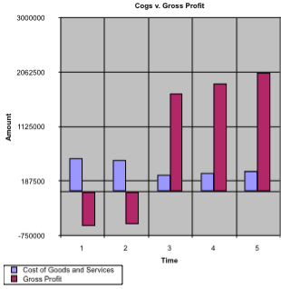
This is a graphical comparison of Cost of Goods and Services in relation to Gross Profit. It is readily apparent from the graph that in year 3 of the analysis Gross Profit significantly out measures Cost of Goods and Services; which contributes to a higher Net Income throughout the projections.

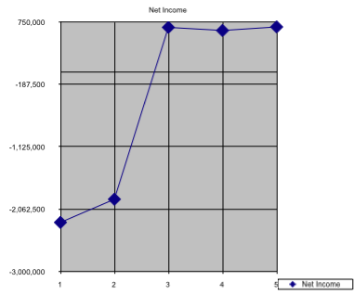
This graph represents the overall increase in NNVC’s revenue year over year. As this represents the worst case scenario for the company, i.e. not securing a deal with a larger pharmaceutical company, this is projected to be the lowest level of Net Income for NNVC. With this said, NNVC experiences a 64% increase in Net Income from year 2 to year 3.

FINANCIAL MODEL #2, 1 PHARMACEUTICAL DEAL
 |  |  | Projected | Projected | Projected
INCOME STATEMENT | 2007 | 2008 | 2009 | 2010 | 2011
Revenues | 0 | 0 | 8500000
Percent Growth | na | na | na | 10.00% | 10.00%
Revenues | 0 | 0 | 8500000 | 9350000 | 10285000
COGS | 575715 | 550273
As % of Revenue | 0 | 0 | 15% | 15% | 15%
COGS | 575715 | 550273 | 1275000 | 1402500 | 1542750
GROSS PROFIT | -575715 | -550273 | 7225000 | 7947500 | 8742250
Gross Margin | 0 | 0 | 0.85 | 0.85 | 0.85
SGA | 1732285 | 1408932
As % of Revenues | 0 | 0 | 15.00% | 15.00% | 15.00%
SGA | 1732285 | 1408932 | 1275000 | 1402500 | 1542750
Operating Expenses | 2308000 | 1793155
As % of Revenues | 0 | 0 | 30% | 30% | 30%
Operating Expenses | 2308000 | 1793155 | 2550000 | 2805000 | 3085500
EBITDA | -2308000 | -1959205 | 3400000 | 3740000 | 4114000
EBITDA Margin | 0 | 0 | 0.4 | 0.4 | 0.4
Depreciation/Ammor | 1615 | 4783
As % of Net PPE | N/A | 25.87223454 | 26% | 26% | 26%
As % of Revenue | 0 | 0
Depreciation/Ammor | 1615 | 4783 | 17024.7065 | 12682.3563 | 9384.94367
EBIT | -2306385 | -1954422 | 3382975 | 3727318 | 4104615
EBIT Margin | 0 | 0 | 0.4 | 0.4 | 0.4
Interest Income | 50937 | 47570
Surplus Funds |  |  | 165235.15 | 10727.1 | 0
Cash |  |  | 60541.8 | 60541.8 | 60541.8
ST Investments |  |  | 0 | 0 | 0
Interest Income | 50937 | 47570 | 225776.95 | 71268.9 | 60541.8
EBT | -2255448 | -1906852 | 3608752 | 3798587 | 4165157
EBT Margin | 0 | 0 | 0.42455908 | 0.40626594 | 0.40497392
Provison for Taxes | 0 | 0
Tax Rate | 0 | 0 | 33% | 33% | 33%
Provison for Taxes | 0 | 0 | 1190888.24 | 1253533.55 | 1374501.76
Net Income | -2255448 | -1906852 | 2417864 | 2545053 | 2790655
Net Margin | 0 | 0 | 0.28445458 | 0.27219818 | 0.27133253
 |  |  | Projected | Projected | Projected
BALANCE SHEET | 2007 | 2008 | 2009 | 2010 | 2011
ASSETS
Surplus Funds |  |  | 6180322 | 429084 | 0
Interest Rate % |  |  | 5% | 5% | 5%
Interest Income |  |  | 165235.15 | 10727.1 | 0
Cash | 967797 | 1210836 | 1210836 | 1210836 | 1210836
As % of Revenue | 0 | 0
Cash | 967797 | 1210836 | 1210836 | 1210836 | 1210836
Interest Rate |  |  | 5.00% | 5.00% | 5.00%
Interest Income |  |  | 60541.8 | 60541.8 | 60541.8
Other Current Assets | 5000 | 179050
As % of Revenue | 0 | 0 | 5% | 5% | 5%
Other Current Assets | 5000 | 179050 | 425000 | 467500 | 514250
Current Assets | 972797 | 1389886 | 1635836 | 1678336 | 1725086
Net PPE | 18487 | 65803
Depreciation | 1615 | 4783 | 17024.7065 | 12682.3563 | 9384.94367
Net PPE | 18487 | 65803 | 48778.2935 | 36095.9371 | 26710.9935
Intangibles | 7215 | 6962
Ammortization |  |  | 5 | 5 | 5
Intangibles | 7215 | 6962 | 6957 | 6952 | 6947
Total Assets | 998499 | 1462651 | 1691571.29 | 1721383.93 | 1758743.99
LIABILITIES
Accounts Payable | 334883 | 234375
As % of Revenue | 0 | 0
Days of COGS | 212.31389 | 155.4626067 | 80 | 80 | 80
Accounts Payable | 334883 | 234375 | 279452.05 | 307397.26 | 338136.98
Other Current Liabilities | 515000 | 278842
As % of Revenues | 0 | 0 | 5% | 5% | 5%
Other Current Liabilities | 515000 | 278842 | 425000 | 467500 | 514250
Current Liabilities | 849883 | 513217 | 704452.05 | 774897.26 | 852386.98
Necessary to Finance | 0 | 0 | 658633.89 | 446753.83 | 256508.58
Interest Rate |  |  | 2.00% | 10.00% | 10.00%
Interest Expense |  |  | 6586.3389 | 55269.386 | 35163.120
Total Liabilities | 1364883 | 792059 | 704452.05 | 774897.26 | 852386.98
EQUITY
Common Stock | 114069 | 119241 | 125203.05 | 131463.20 | 138036.36
Other Equity | 6209269 | 1257098
As % of Equity | 0 | 0 | 3% | 4% | 5%
Other Equity | 6209269 | 1257098 | 213350 | 374000 | 514250
Total SH Equity | 6323338 | 1376339 | 338553.05 | 505463.20 | 652286.36
Total Liab & SH Equity | 7688221 | 2168398 | 1043005.1 | 1280360.4 | 1504673.3

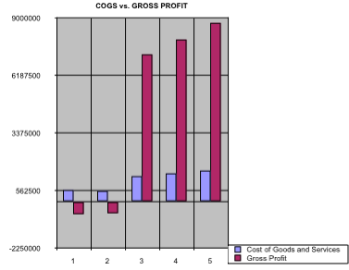
This graph shows the relationship between Cost of Goods and Services to Gross Profit in the event NanoViricides secures one pharmaceutical deal. The difference between COGS and Gross Profit in year 3 is also greater in this model than the first. Here NNVC experiences an astounding 1400% increase in Gross Profit from a deficit of 550,273 to a surplus of 7.2 million.
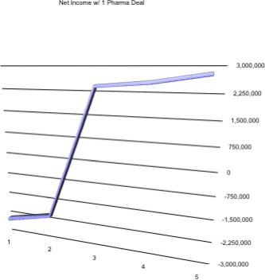

The above chart demonstrates the increase in Net Income experienced by NanoViricides only securing 1 Pharmaceutical deal. We can observe again the dramatic spike in Net Income after year 2, after which Net Income increases slightly over the next two years. In this model, Nanoviricides, experiences a 226% increase in Net Income with only 1 pharmaceutical deal.

FINANCIAL MODEL #3, TWO PHARMACEUTICAL DEALS
NANOVIRICIDES
 |  |  | Projected | Projected | Projected
INCOME STATEMENT | 2007 | 2008 | 2009 | 2010 | 2011
Revenues | 0 | 0 | 25000000
Percent Growth | na | na | na | 10.00% | 10.00%
Revenues | 0 | 0 | 25000000 | 27500000 | 30250000
COGS | 575715 | 550273
As % of Revenue | 0 | 0 | 15% | 15% | 15%
COGS | 575715 | 550273 | 3750000 | 4125000 | 4537500
GROSS PROFIT | -575715 | -550273 | 21250000 | 23375000 | 25712500
Gross Margin | 0 | 0 | 0.85 | 0.85 | 0.85
SGA | 1732285 | 1408932
As % of Revenues | 0 | 0 | 15.00% | 15.00% | 15.00%
SGA | 1732285 | 1408932 | 3750000 | 4125000 | 4537500
Operating Expenses | 2308000 | 1793155
As % of Revenues | 0 | 0 | 30% | 30% | 30%
Operating Expenses | 2308000 | 1793155 | 7500000 | 8250000 | 9075000
EBITDA | -2308000 | -1959205 | 10000000 | 11000000 | 12100000
EBITDA Margin | 0 | 0 | 0.4 | 0.4 | 0.4
Depreciation/Ammor | 1615 | 4783
As % of Net PPE | N/A | 25.87223454 | 26% | 26% | 26%
As % of Revenue | 0 | 0
Depreciation/Ammor | 1615 | 4783 | 17024.7065 | 12682.35631 | 9384.94367
EBIT | -2306385 | -1954422 | 9982975 | 10987318 | 12090615
EBIT Margin | 0 | 0 | 0.4 | 0.4 | 0.4
Interest Income | 50937 | 47570
Surplus Funds |  |  | 165235.15 | 18176.64646 | 7449.546455
Cash |  |  | 60541.8 | 60541.8 | 60541.8
ST Investments |  |  | 0 | 0 | 0
Interest Income | 50937 | 47570 | 225776.95 | 78718.44646 | 67991.34646
EBT | -2255448 | -1906852 | 10208752 | 11066036 | 12158606
EBT Margin | 0 | 0 | 0.40835009 | 0.402401312 | 0.401937402
Provison for Taxes | 0 | 0
Tax Rate | 0 | 0 | 33% | 33% | 33%
Provison for Taxes | 0 | 0 | 3368888.24 | 3651791.91 | 4012340.113
Net Income | -2255448 | -1906852 | 6839864 | 7414244 | 8146266
Net Margin | 0 | 0 | 0.27359456 | 0.269608879 | 0.269298059
 |  |  | Projected | Projected | Projected
BALANCE SHEET | 2007 | 2008 | 2009 | 2010 | 2011
ASSETS
Surplus Funds |  |  | 6180322 | 429084 | 297981.8582
Interest Rate % |  |  | 5% | 5% | 5%
Interest Income |  |  | 165235.15 | 18176.64646 | 7449.546455
Cash | 967797 | 1210836 | 1210836 | 1210836 | 1210836
As % of Revenue | 0 | 0
Cash | 967797 | 1210836 | 1210836 | 1210836 | 1210836
Interest Rate |  |  | 5.00% | 5.00% | 5.00%
Interest Income |  |  | 60541.8 | 60541.8 | 60541.8
Other Current Assets | 5000 | 179050
As % of Revenue | 0 | 0 | 5% | 5% | 5%
Other Current Assets | 5000 | 179050 | 1250000 | 1375000 | 1512500
Current Assets | 972797 | 1389886 | 2460836 | 2585836 | 2723336
Net PPE | 18487 | 65803
Depreciation | 1615 | 4783 | 17024.7065 | 12682.35631 | 9384.94367
Net PPE | 18487 | 65803 | 48778.2935 | 36095.93719 | 26710.99352
Intangibles | 7215 | 6962
Ammortization |  |  | 5 | 5 | 5
Intangibles | 7215 | 6962 | 6957 | 6952 | 6947
Total Assets | 998499 | 1462651 | 2516571.294 | 2628883.937 | 2756993.994
LIABILITIES
Accounts Payable | 334883 | 234375
As % of Revenue | 0 | 0
Days of COGS | 212.3138966 | 155.4626067 | 80 | 80 | 80
Accounts Payable | 334883 | 234375 | 821917.8082 | 904109.589 | 994520.5479
Other Current Liabilities | 515000 | 278842
As % of Revenues | 0 | 0 | 5% | 5% | 5%
Other Current Liabilities | 515000 | 278842 | 1250000 | 1375000 | 1512500
Current Liabilities | 849883 | 513217 | 2071917.808 | 2279109.589 | 2507020.548
Necessary to Finance | 0 | 0 | 0 | 0 | 0
Interest Rate |  |  | 2.00% | 10.00% | 10.00%
Interest Expense |  |  | 0 | 0 | 0
Total Liabilities | 1364883 | 792059 | 2071917.808 | 2279109.589 | 2507020.548
EQUITY
Common Stock | 114069 | 119241 | 125203.05 | 131463.2025 | 138036.3626
Other Equity | 6209269 | 1257098
As % of Equity | 0 | 0 | 3% | 4% | 5%
Other Equity | 6209269 | 1257098 | 627500 | 1100000 | 1512500
Total SH Equity | 6323338 | 1376339 | 752703.05 | 1231463.203 | 1650536.363
Total Liab & SH Equity | 7688221 | 2168398 | 2824620.858 | 3510572.792 | 4157556.911

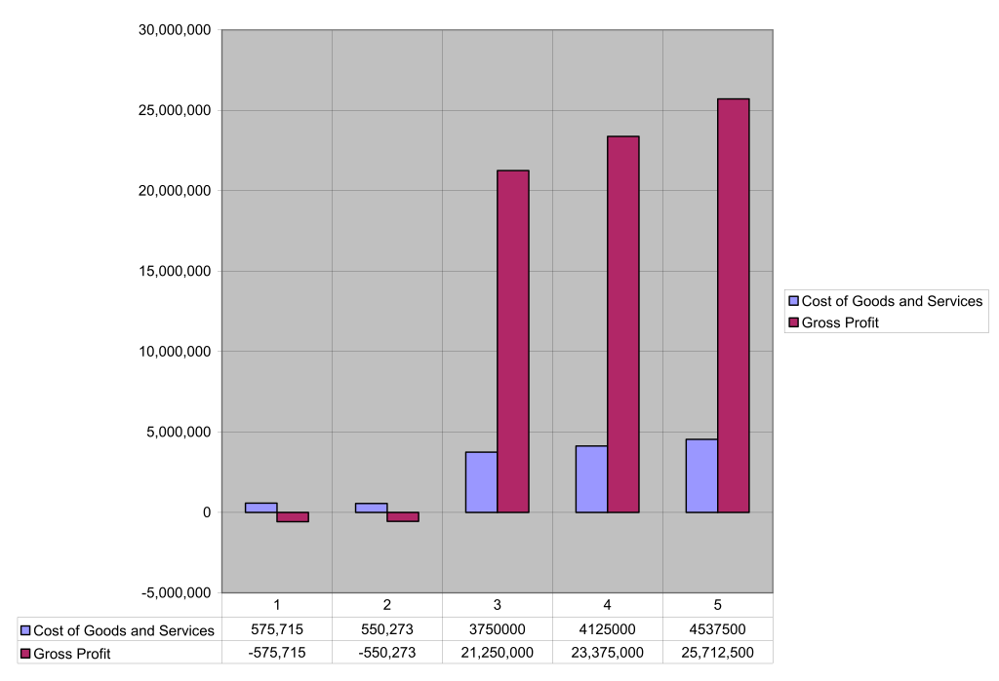

This chart represents the relationship between Cost of Goods and Services and Gross Profit based on the assumptions for this model. As we can see, Gross Profit grows exponentially during year 3 in relations to the Gross Profits in year 2. In years, 4 and 5 we see gradual yet steady increase in the Gross Profit margin relatively. Cost of Goods and Services appear to grow at much smaller increments during the same time frame.
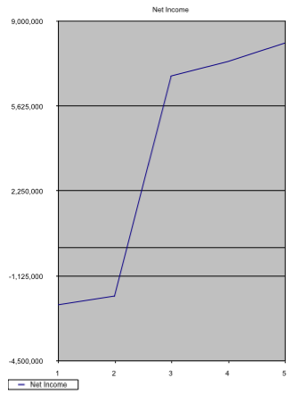
This is a graphical representation of the increase in Net Income experienced by NanoViricides with the securing of two pharmaceutical deals comprised of up-front payments and periodic milestone payments as well.

TECHNICAL ANALYSIS OF NANOVIRICIDES, INC

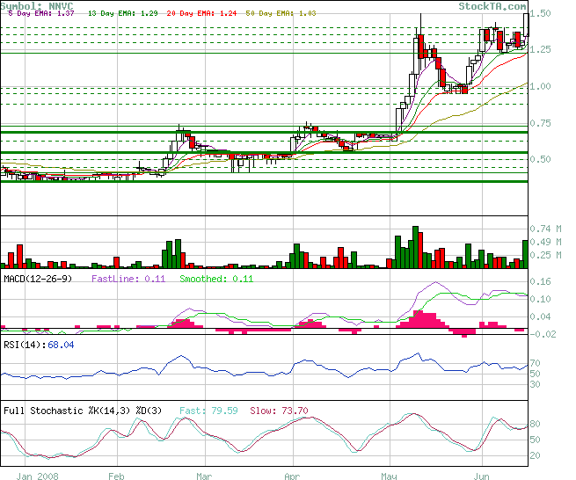

The first place to begin a comprehensive technical analysis is by examining the candlestick chart of the company’s stock. NNVC has been trading above all of its moving averages (5, 13, 20 and 50 day Exponential Moving Average). This indicates a bullish trading pattern and this pattern is confirmed when examining the candlesticks more closely. Looking closely at the NNVC chart we can see that for the most part of the month of May, the “real bodies” in the candlesticks are white, indicating a strong bullish trading pattern. “Real bodies” are defined as the rectangular section of the candlestick, in a sense they are the “stick” of the candle. The longer the real body is the stronger the trading indication. Likewise, if the real bodies are white this indicates the bulls are in control of the stock and conversely if the real bodies are red or black, this indicates the bears are doing the majority of trading. As the chart indicates the majority of the month of May and the first part of June, the bulls have had a firm grasp on NNVC.

Also, NNVC has formed a chart pattern referred to as a “Cup and Handle” pattern. Generally, when a security has formed this type of trading pattern this indicates a bullish trend coming out of the “handle” portion. As we can see the entire month of May NNVC formed the cup and now, in the first part of June it has entered into the “handle”. This indicates NNVC could be entering a strong bullish trading pattern. Evidence of this pattern can already be seen in the intra-day chart for June 17, 2008. This chart is shown below.

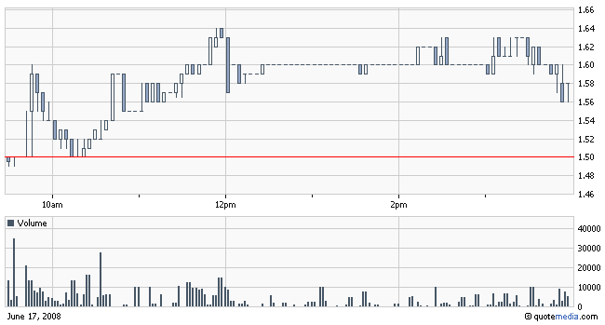

The “handle” of the cup/handle pattern reaches until June 16 2008. The following trading day, June 17, 2008, NNVC hit and closed at a new 52-week high of $1.52 a share on roughly 640,000 shares traded. Although this is only one indication, it may suggest that NNVC is entering a bullish trend after exiting its most recent chart pattern. Further trading sessions will be examined closely to determine if NNVC remains in a bullish trend, there will be natural profit taking; however, the technical indications are NNVC will be in a long term bullish pattern. Furthermore this is evidence to suggest that NNVC has “broken out” of its previous resistance level of $1.52; this is supported further by the increased level of volume exhibited in recent trading sessions.

EXPONENTIAL MOVING AVERAGE
The EMA applies weighting factors which decrease exponentially. The weighting for each older data point decreases exponentially, giving much more importance to the newer data points without disregarding the older ones. EMA’s will give bullish signals when trading above trailing EMA’s and below the current price and vice versa. Observing the chart for NNVC reveals NNVC is trading above all major moving averages. This indicates the stock is in a strong bullish trading pattern and may remain there for another moving average period.
In NNVC’s chart the EMA’s are represented by the colored lines following the stocks trading pattern in the candle stick chart. There we can observe that all the EMA’s are trading below the current price, therefore confirming the analysis that EMA’s demonstrate a very bullish trading pattern. The EMA is calculated by utilizing the following formula:
Current Price-Previous EMA * Multiplier + Previous EMA
In this case the multiplier was 2/(N+1) where N= the number of periods, i.e. 5,13,20,50.

MACD
Moving Average Convergence Divergence (MACD) analysis measures the frequency by which the moving averages come together or move apart. The 12 period moving average is generally classified as the “fast” moving average; while the 26 period is considered the “slow” moving average. Each bar on the histogram represents the individual differences between the two MACD lines. The “Zero line” represents the trade line. Therefore if the MACD lines cross the zero line upward, this indicates a bullish trend; conversely, when the MACD lines cross the zero line downward this is indicative of a bearish trend. The relative difference between these two MACD lines forms the histogram seen on the zero line. This is a good indicator of the trend of a security.
Looking at the MACD lines from the NNVC chart we can observe the MACD lines crossed over the zero line in positive territory in early February 2008. This coincides with the development of the bullish trading pattern evident on the NNVC chart. The MACD lines have been above the zero line since early February. When the MACD lines broke positive, NNVC was trading at approximately $0.40 a share on thin volume. At the close of trading on June 18, 2008 NNVC closed at $1.66 on 561K shares traded. NNVC closed above its new 52 week high—further suggesting the long term bullish trend. Additionally, NNVC has experienced a 315% increase in stock price since the MACD lines broke positive in early February.
In early May of ’08, the MACD rose to their highest levels since early 2006. In early May, the MACD broke decidedly positive with the “fast-line” rising to 0.16. This coincided with a major uptrend in both price and overall volume in NNVC stock. Furthermore, this also signaled the entry of NNVC into the “cup and handle” chart patterned previously analyzed. The behavior of the MACD lines coupled with the previous trading activity seems to suggest that NNVC has entered or will be entering a bullish trading pattern.

RELATIVE STRENGTH INDEX (RSI)
The RSI is a technical indicator used to measure the magnitude of recent gains over a given period of time to determine whether a particular security is either overbought or oversold. RSI ranges from 0 to 100. An asset is designated overbought when its RSI reaches 70 or higher. Conversely, an asset is said to be oversold when its RSI reaches 30.
Relative Strength is calculated using a sophisticated statistical formula taking into account the exponential moving averages of a given period on up days vs. ema’s of a given period for down days. The formula is represented as follows:
RS=EMA[N] of Up-days
EMA[N] of Down-days
In this representation, N is the smoothing factor used in calculations in order to adjust for the relative weights used in calculating the EMA’s. In this particular instance, N was calculated at 27 or using its α equivalent, 1/14. The smoothing factor reflects the Relative Strength calculated over a period of 14 days. The formula used in calculating the RSI is as follows:
RSI=100-(100*1/1+RS)
After running the NNVC data through the formulas, NNVC’s RSI was determined to be 68.04, as we display in the chart above. This RSI is treading very closely to the overbought mark. Normally this would trigger a “sell” indication but there is another factor which may prolong the triggering of this indication. NNVC has continuously released good scientific data (i.e. the press release dated June 16, 2008 describing their latest HIV test results) which in turn places buying pressure on the stock. Therefore, the RSI will technically show NNVC is venturing into overbought territory; however it is unlikely the RSI will trigger a trend reversal.
STOCHASTIC OSCILLATOR ANALYSIS
A Stochastic Oscillator is a momentum indicator to compare the closing price of a commodity to its price range over a given time span. The theory behind this analysis is that prices tend to close near past highs in a bull market and near their lows in bear markets. The two indicators utilized are %K (fast) and %D (slow) in order to analyze the speed with which prices are changing. The formula employed for %K is as follows:
%K=CP-L14
H14-L14

This quantity is then multiplied by a factor of 100. %D is calculated by deriving the Simple Moving Average of %K across three (3) periods. The crossing of %K and %D signals a pattern similar to MACD. %K crossing %D in an upward manner is a bullish indicator, and the crossing of %D in a downward manner is a bearish indicator. In high volatility situations (i.e. when a stock is favored by day traders), the SMA of %D can smooth out the oscillation curve. Also, Stoch Analysis is key during overbought or oversold periods.
For NNVC, the Stoch Analysis demonstrates the security is hovering in the high 70’s. (See Chart for Stoch Analysis). Both the %K and %D are showing signs NNVC may be nearing the peak of its bullish trend. Furthermore, %K is 79.59, while %D is 73.70; this further indicates NNVC may be reaching a critical overbought price point; however further analysis will be needed to confirm these trends. Similar to the RSI analysis, the Stochastic’s on NNVC are purely academic at this point. The release of further scientific data will drive the price and volume higher as well as the Stochastic Oscillator. Although the oscillator will indicate NNVC has entered into overbought territory, it is unlikely this indicator will cause a trend reversal.

RECOMMENDATION AND PRICE TARGET
RECOMMENDATION: BUY
12-MONTH PRICE TRAGET: $4/ SHARE

